**1=> Problem Statement 1:**  Jimmy, from the healthcare department, has requested a report that shows how the number of treatments each age category of patients has gone through in the year 2022.

The age category is as follows, Children (00-14 years), Youth (15-24 years), Adults (25-64 years), and Seniors (65 years and over).

Assist Jimmy in generating the report.

**Query:**

hive>create view p11 as select e.category, count(*) as count from (select (case when DATEDIFF("2022-12-01",p.dob) / 365.25 <=14 then "children"

when DATEDIFF("2022-12-01",p.dob) / 365.25 <=24 then "youth"

when datediff("2022-12-01",p.dob) <= 64 then "Adults"

else "Seniors"

end) as category from treatment t join patient p on t.patientID=p.patientID where year(t.`date`)=2022) e group by e.category;

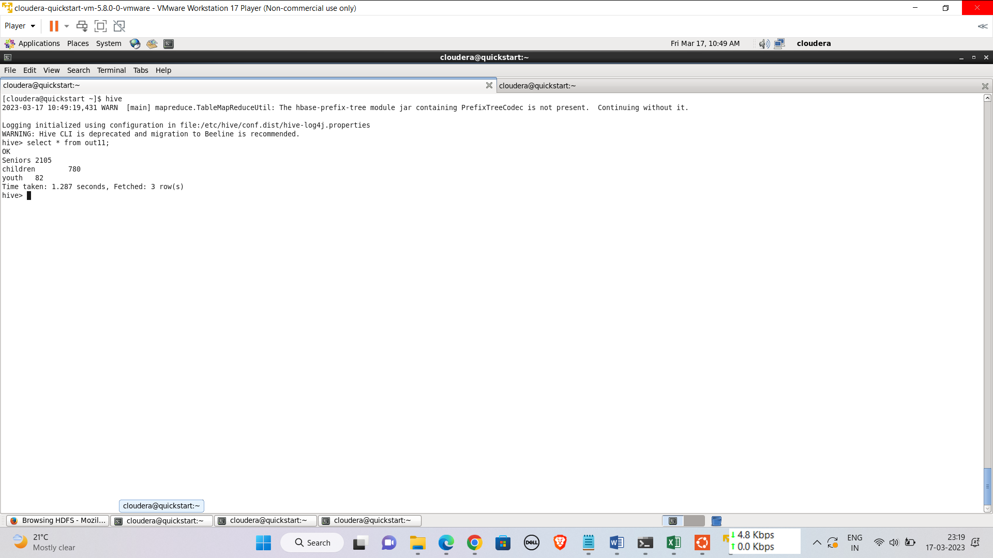

**External Table:**

> create external table out11(category varchar(10), count int);

OK

Time taken: 0.049 seconds

hive> insert overwrite table out11 select * from p11;

**Creating empty table in Mysql:**

mysql> create table out11(category varchar(10),count int);

Query OK, 0 rows affected (0.01 sec)

**Sqoop Export:**

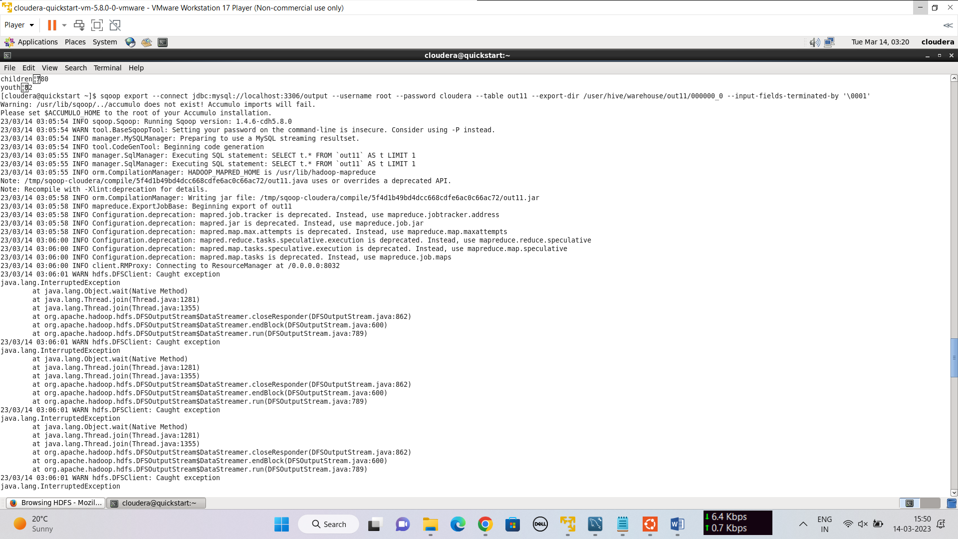

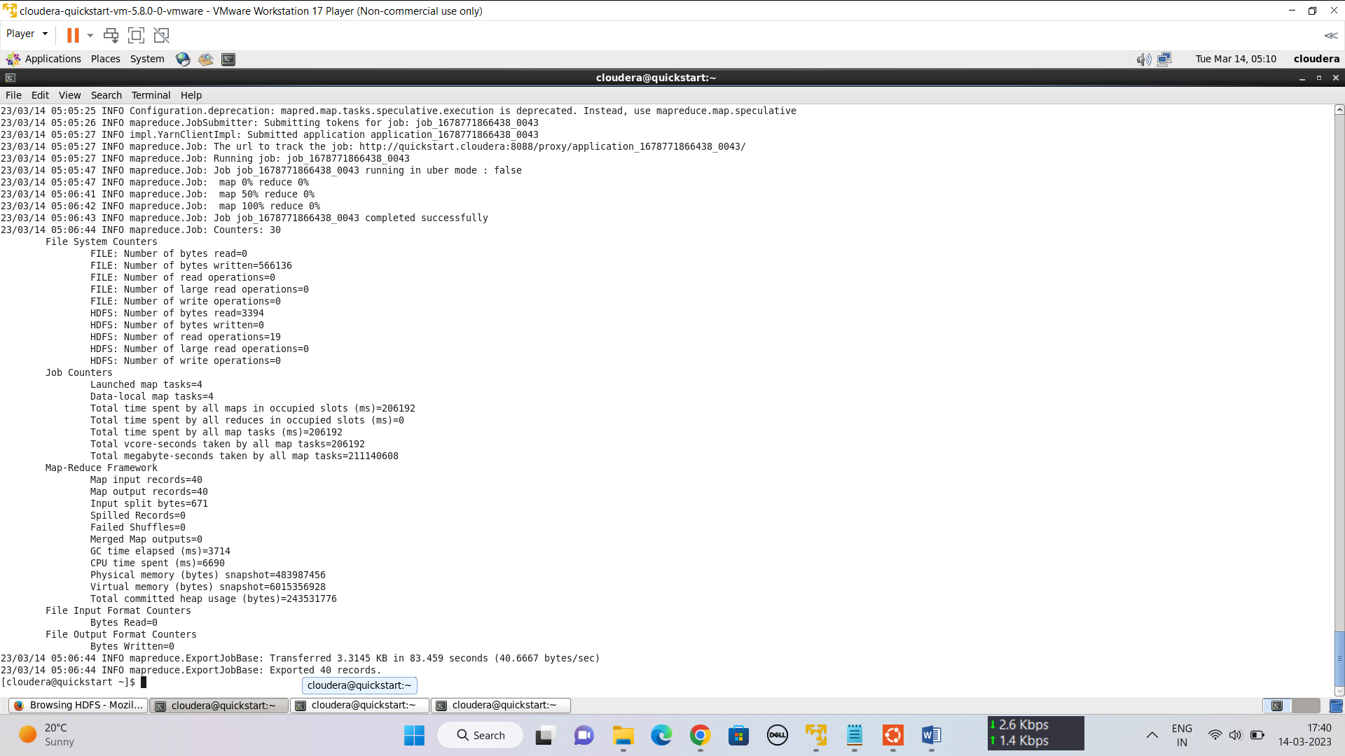

**2=> Problem Statement 2:**  Jimmy, from the healthcare department, wants to know which disease is infecting people of which gender more often.

Assist Jimmy with this purpose by generating a report that shows for each disease the male-to-female ratio. Sort the data in a way that is helpful for Jimmy.

**Hive Query:**

create view p12 as select d.diseasename, p.gender, count(*) as cnt from disease d join treatment t on d.diseaseid = t.diseaseid join person p on p.personid = t.patientid group by d.diseasename, p.gender order by cnt;

create view p121 as select a.d diseasename, b.cnt male, a.cnt female from (select diseasename d , cnt from p12 where gender = 'female')a join (select diseasename d, cnt from p12 where gender='male')b on a.d=b.d;

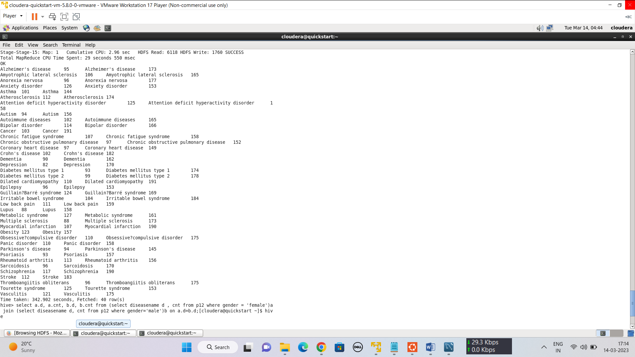

**External Table:**

hive> create external table out12(diseasename string, male int,female int);

OK

Time taken: 1.714 seconds

hive> insert overwrite table out12 select * from p121;

**Creating empty table in Mysql:**

mysql> create table out12(diseasename varchar(50),male int, female int);

Query OK, 0 rows affected (0.02 sec)

**Sqoop Export:**

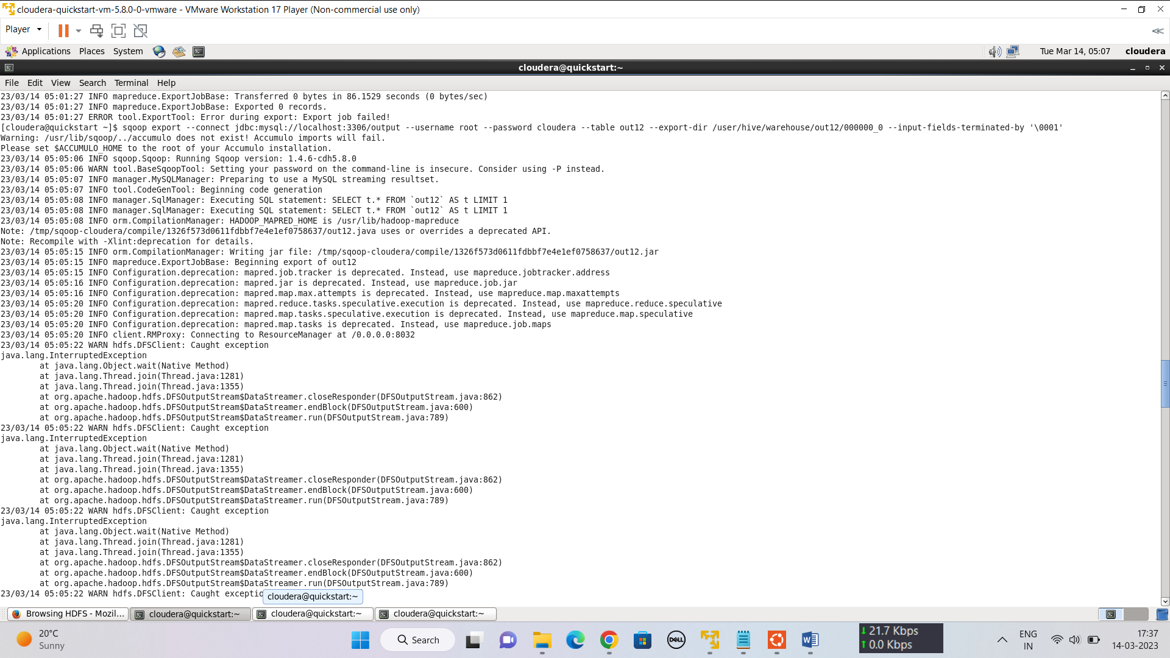



**3=> Problem Statement 3:** Jacob, from insurance management, has noticed that insurance claims are not made for all the treatments. He also wants to figure out if the gender of the patient has any impact on the insurance claim. Assist Jacob in this situation by generating a report that finds for each gender the number of treatments, number of claims, and treatment-to-claim ratio. And notice if there is a significant difference between the treatment-to-claim ratio of male and female patients.

**Hive Query:**

create view p13 as select p.gender, count(t.treatmentid), count(t.claimid), count(t.treatmentid)/count(t.claimid) from treatment t join person p on t.patientid=p.personid group by p.gender;

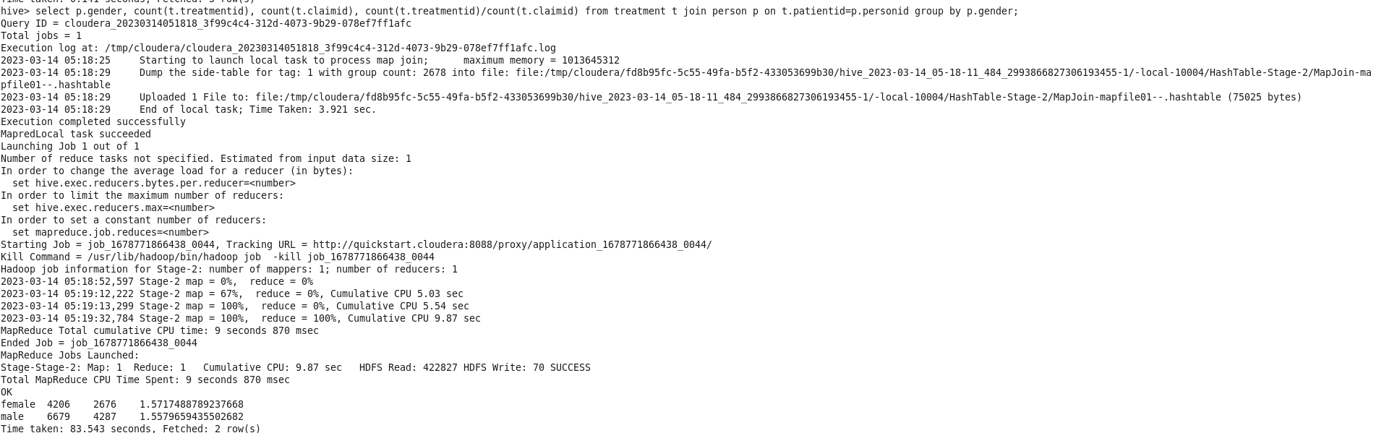

**External Table:**

hive> create external table out13(Gender string, treatments int, claims int, ratio decimal(10,5));

OK

Time taken: 0.234 seconds

hive> insert overwrite table out13 select * from p13;

**Sqoop Export:**

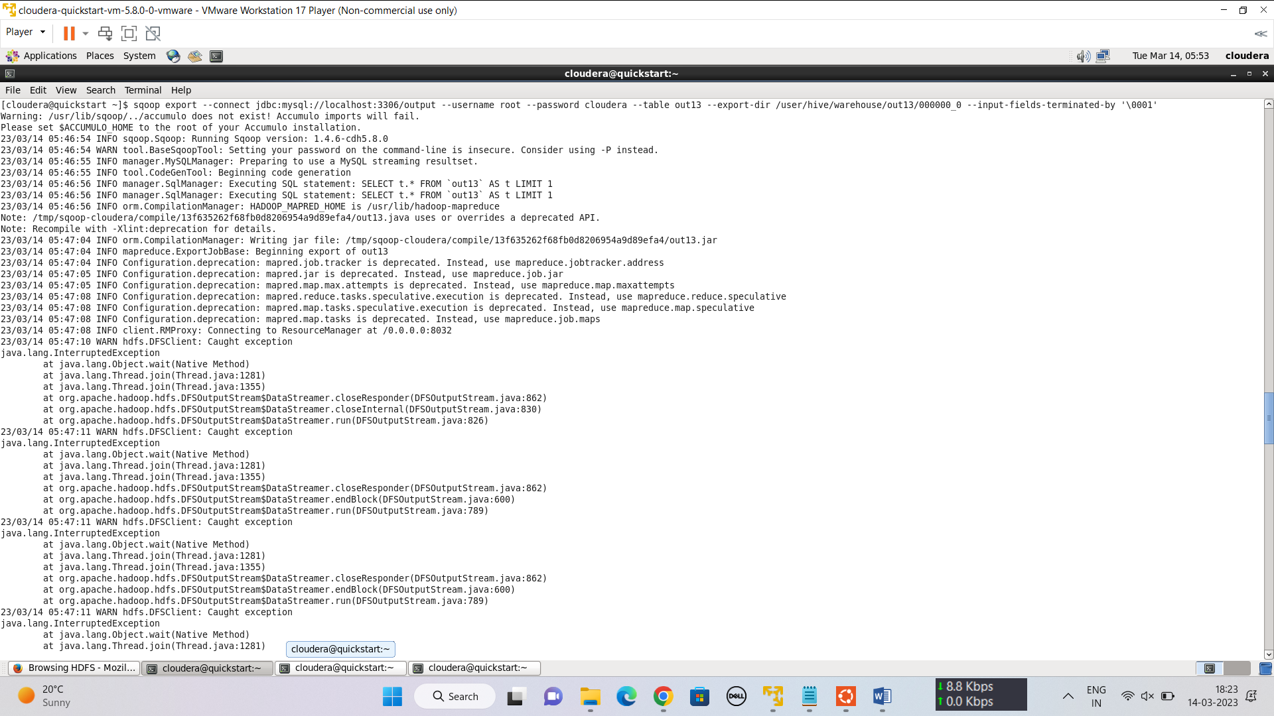

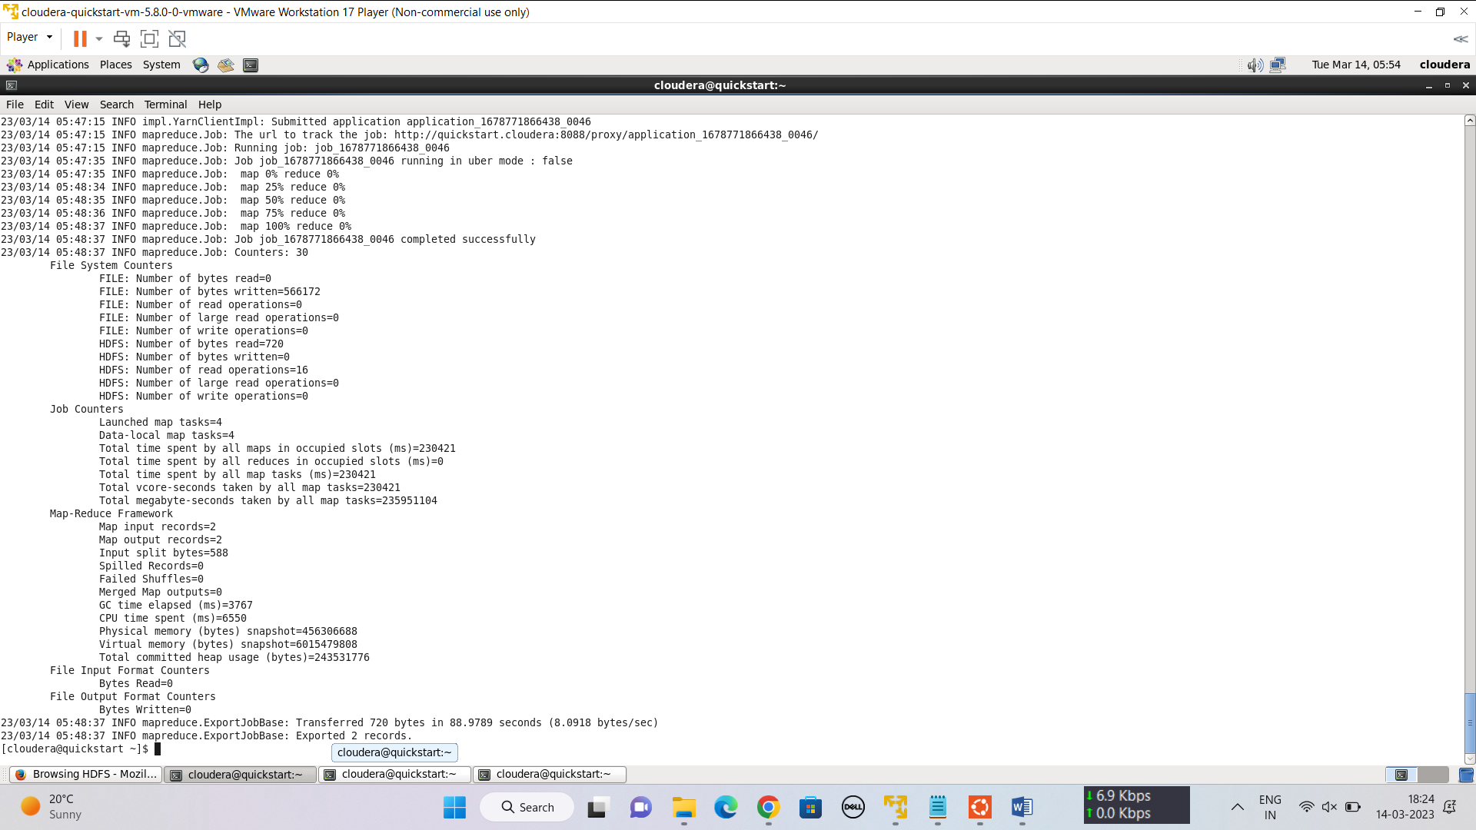

**=>4 Problem Statement 4:** The Healthcare department wants a report about the inventory of pharmacies. Generate a report on their behalf that shows how many units of medicine each pharmacy has in their inventory, the total maximum retail price of those medicines, and the total price of all the medicines after discount.

Note: discount field in keep signifies the percentage of discount on the maximum price.

**Hive Query:**

hive> create view p14 as select p.pharmacyid, round(sum( k.quantity*m.maxPrice),5), round(sum((k.quantity*m.maxPrice)-(k.quantity*m.maxPrice*k.discount/100)),5) from pharmacy p join keep k on p.pharmacyID=k.pharmacyID join medicine m on k.medicineID=m.medicineID group by p.pharmacyid;

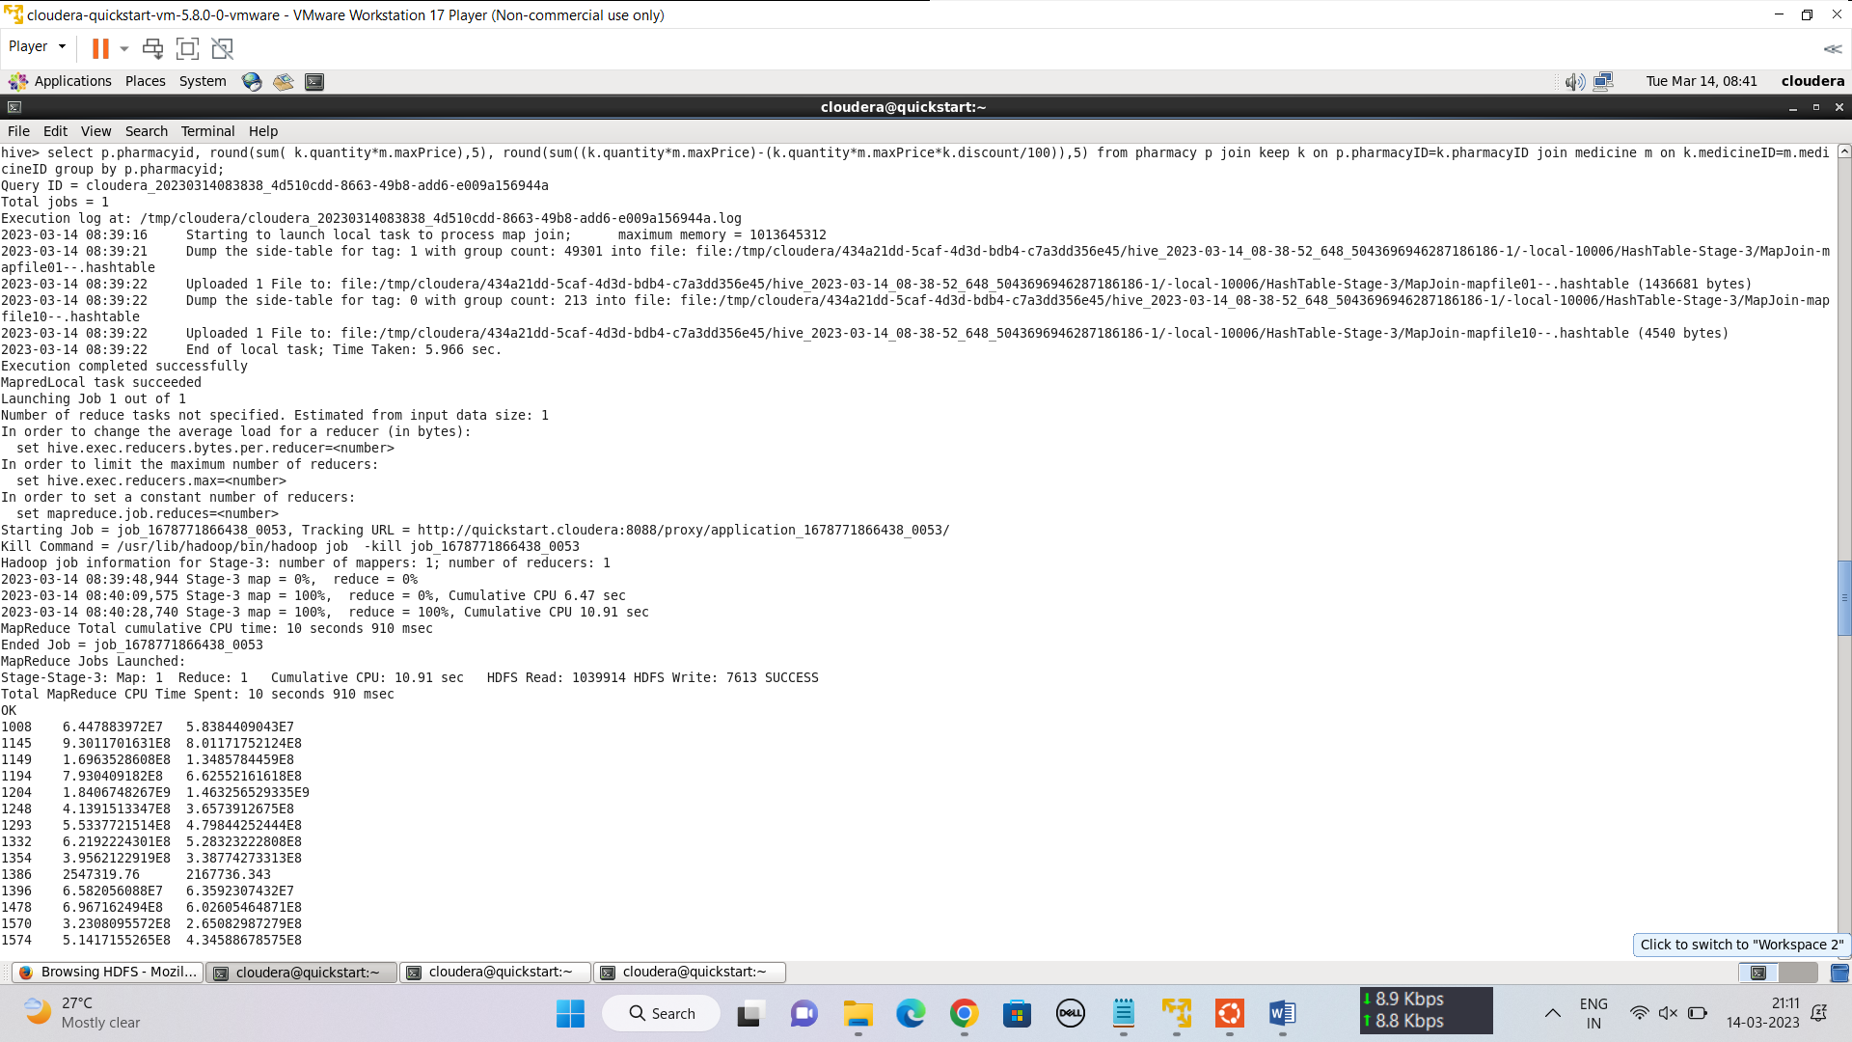

**External Table:**

hive> create external table out14(pharmacyname string, Total decimal(25,5),Discount decimal(25,5));

OK

Time taken: 0.234 seconds

hive> insert overwrite table out14 select * from p14;

**Sqoop Export:**

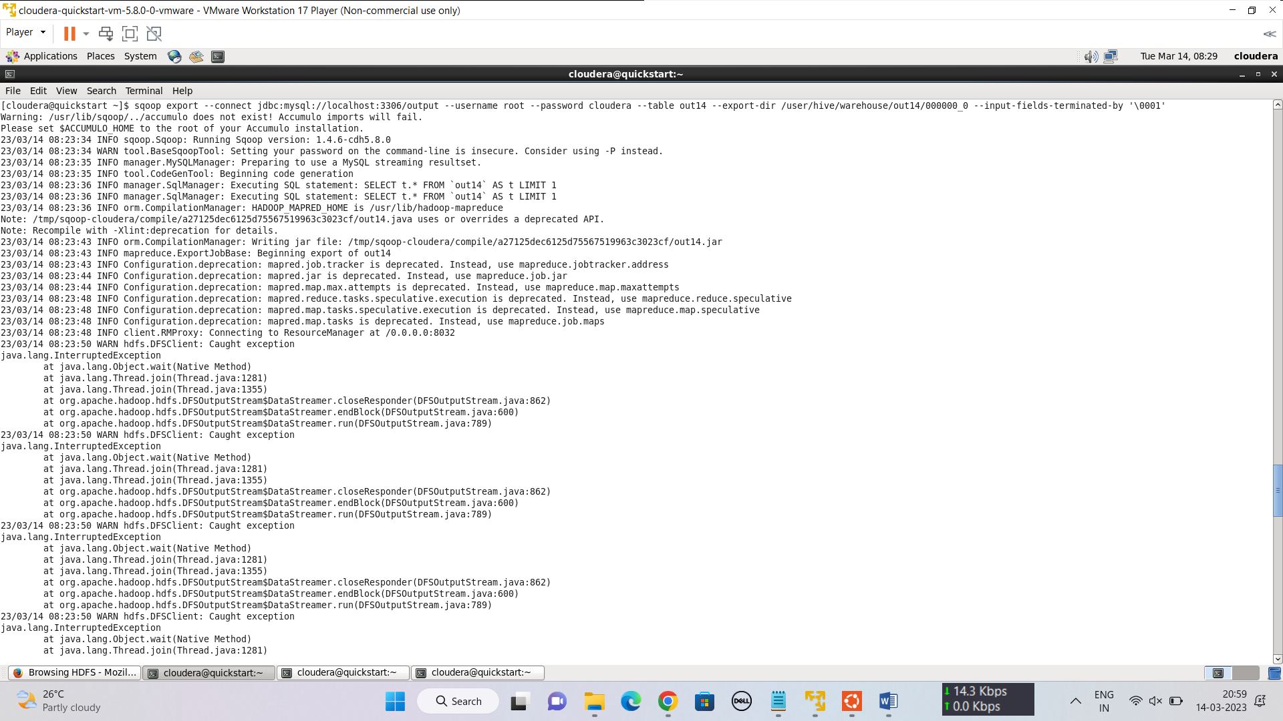

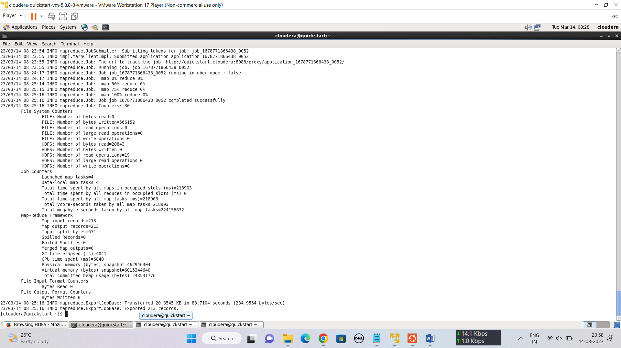

**=>5 Problem Statement 5:**  The healthcare department suspects that some pharmacies prescribe more medicines than others in a single prescription, for them, generate a report that finds for each pharmacy the maximum, minimum and average number of medicines prescribed in their prescriptions.

**Hive Query:**

hive> create view p15 as select pharmacyname, max(cnt) `max`, min(cnt) `min`,avg(cnt) `avg` from (select p1.pharmacyname, p.prescriptionid, sum(c.quantity) cnt from prescription p join pharmacy p1 on p1.pharmacyid = p.pharmacyid join contain c on c.prescriptionid = p.prescriptionid group by p1.pharmacyname,p.prescriptionid)a group by pharmacyname;

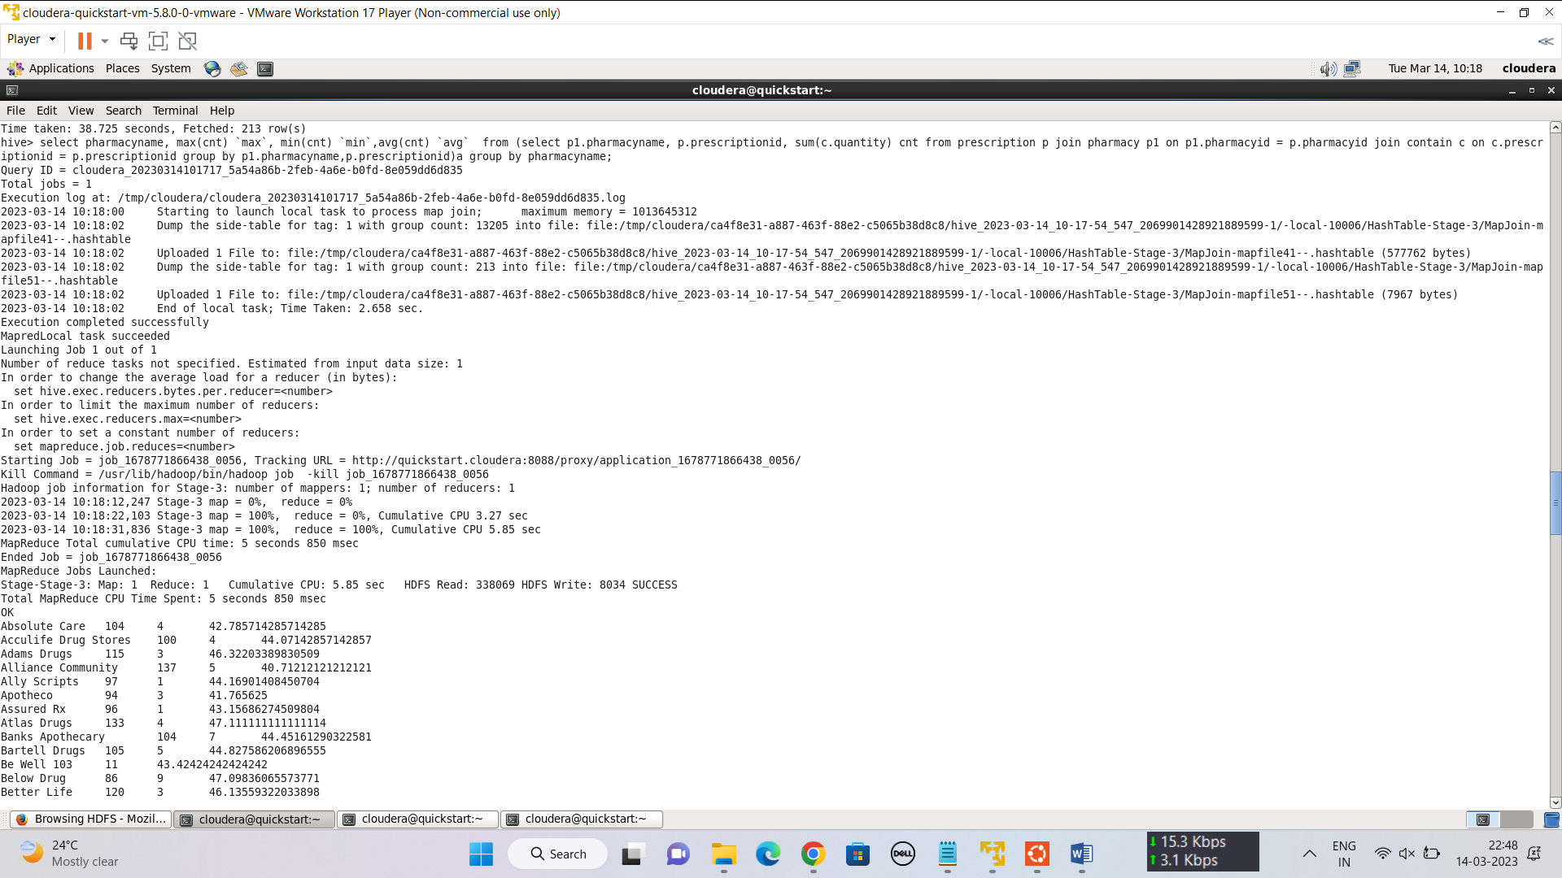

**External Table:**

hive> create external table out15 (pharmacyname string,`max` int, `min` int,avg decimal(10,5));

OK

Time taken: 0.094 seconds

hive> insert overwrite table out15 select * from p15;

**Sqoop Export:**

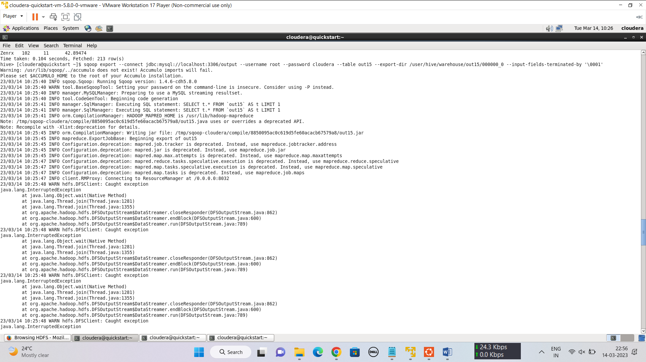

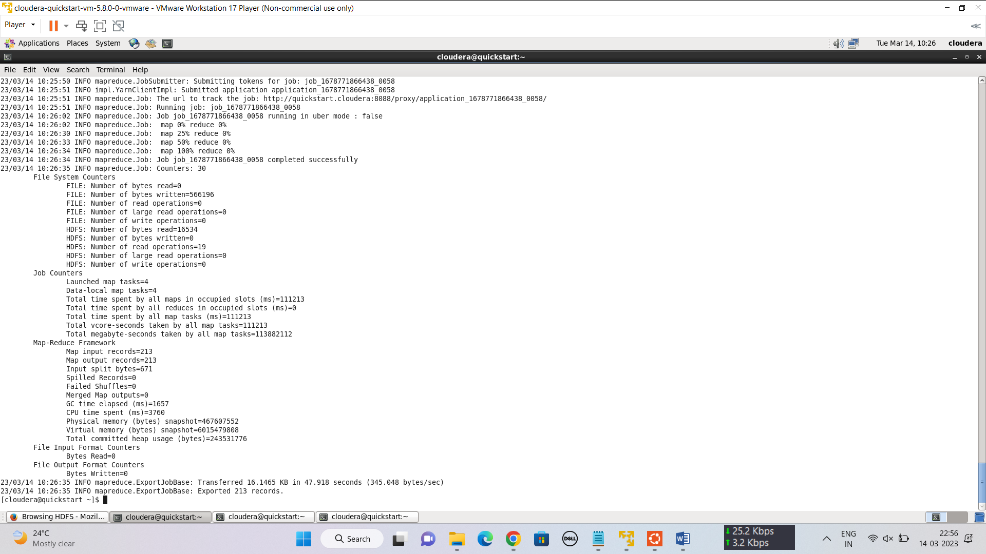

**=>6 Problem Statement 2-1:** A company needs to set up 3 new pharmacies, they have come up with an idea that the pharmacy can be set up in cities where the pharmacy-to-prescription ratio is the lowest and the number of prescriptions should exceed 100. Assist the company to identify those cities where the pharmacy can be set up.

**Creating a partition for address table for state column.**

create external table if not exists address_part (addressid int, address1 string,city string,zip int)comment 'address_partition' partitioned by (state string) row format delimited fields terminated by ',' lines terminated by '\n';

insert into address_partition partition(state) select addressid, address1 , city, zip, state from address;

**Hive Query:**

hive> create view p21 as select x.city, count(phid), sum(cnt), count(phid)/sum(cnt) from (select a.city,p.pharmacyid phid,count(p1.prescriptionid) cnt from address a join pharmacy p on p.addressid = a.addressid join prescription p1 on p1.pharmacyid=p.pharmacyid group by a.city,p.pharmacyid order by a.city)x group by x.city having sum(cnt)>100 order by x.city;

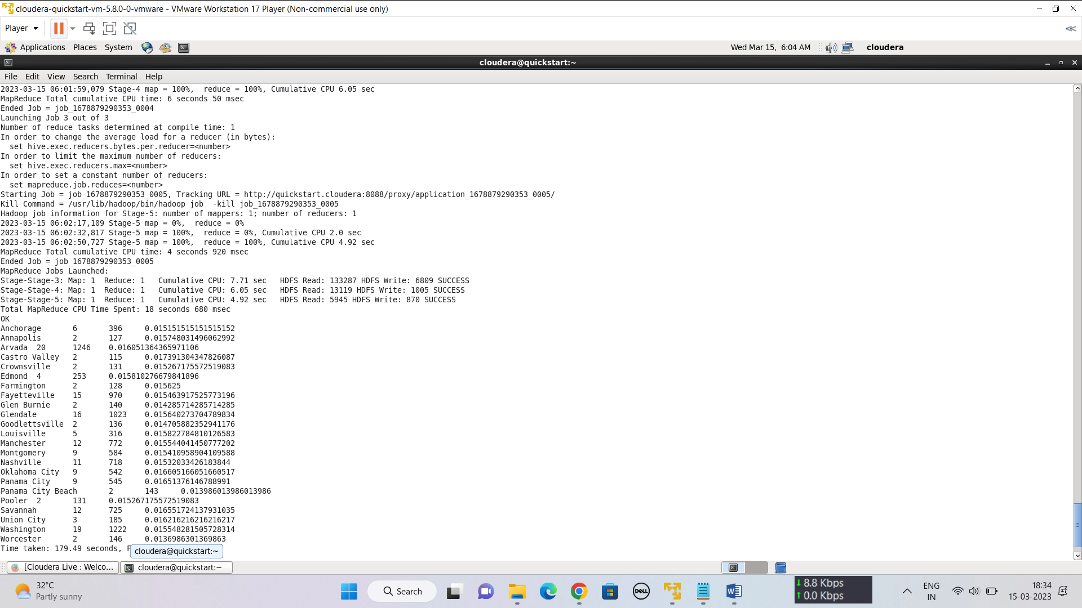

**External Table:**

hive> create external table out21(city string, Pharmacies int, Prescriptions int, Ratio decimal(10,2));

OK

Time taken: 0.404 seconds

hive> insert into out21 select * from p21;

**Sqoop Export:**

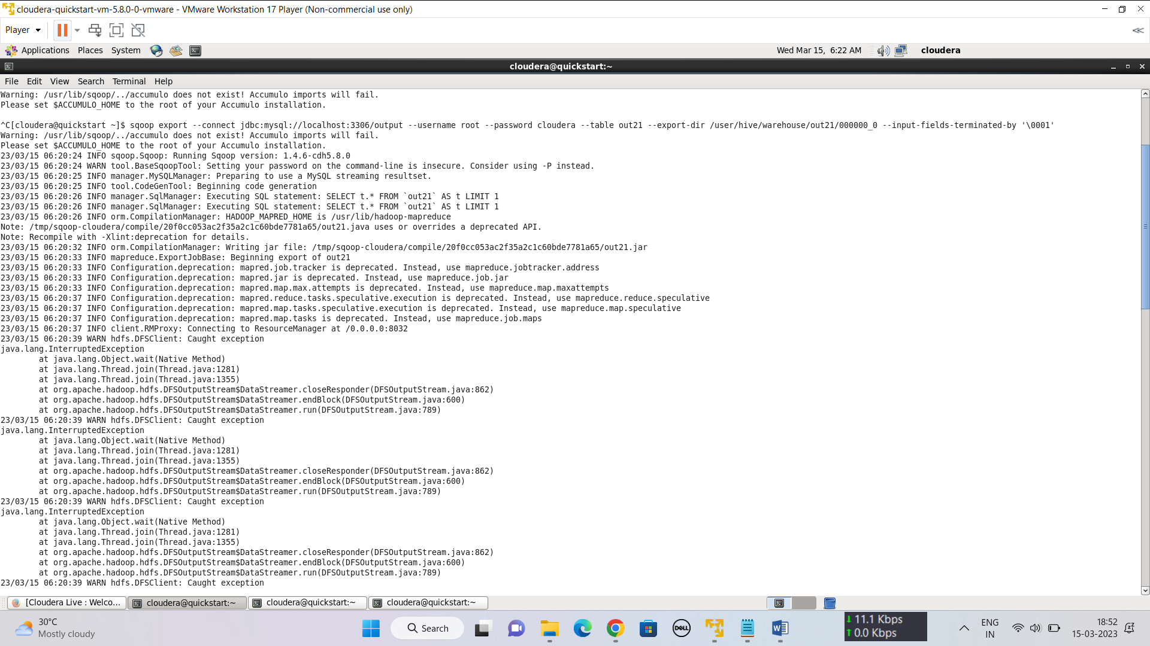

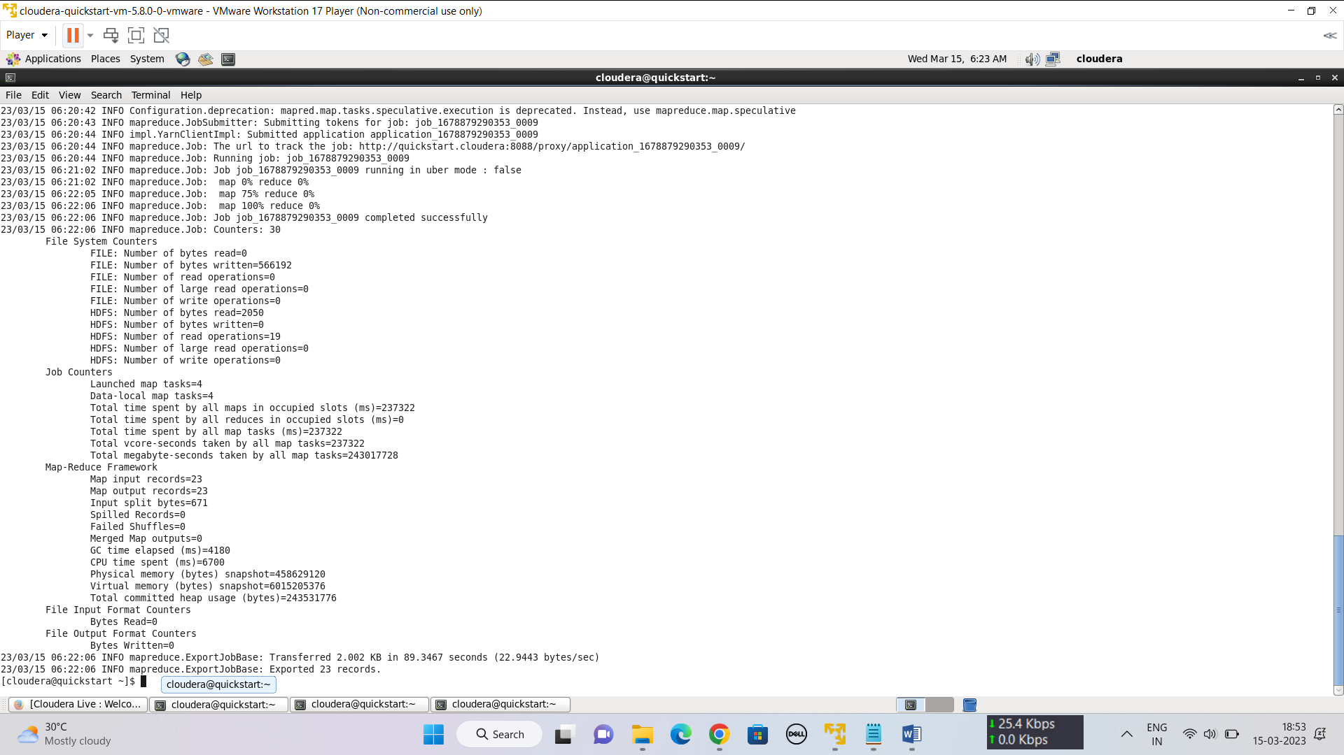

**=>7 Problem Statement 2-2:** The State of Alabama (AL) is trying to manage its healthcare resources more efficiently. For each city in their state, they need to identify the disease for which the maximum number of patients have gone for treatment. Assist the state for this purpose.

Note: The state of Alabama is represented as AL in Address Table.

**Hive Query:**

hive> select city,diseasename, max(cnt) from (select a.city,d.diseasename, count(t.patientid) cnt, dense_rank() over(partition by a.city order by a.city desc, count(t.patientid) desc) rn from treatment t join person p on t.patientid=p.personid join address a on a.addressid = p.addressid join disease d on d.diseaseid = t.diseaseid where a.state = 'AL' group by a.city, d.diseasename order by a.city desc, 3 desc)x where rn=1 group by city,diseasename;

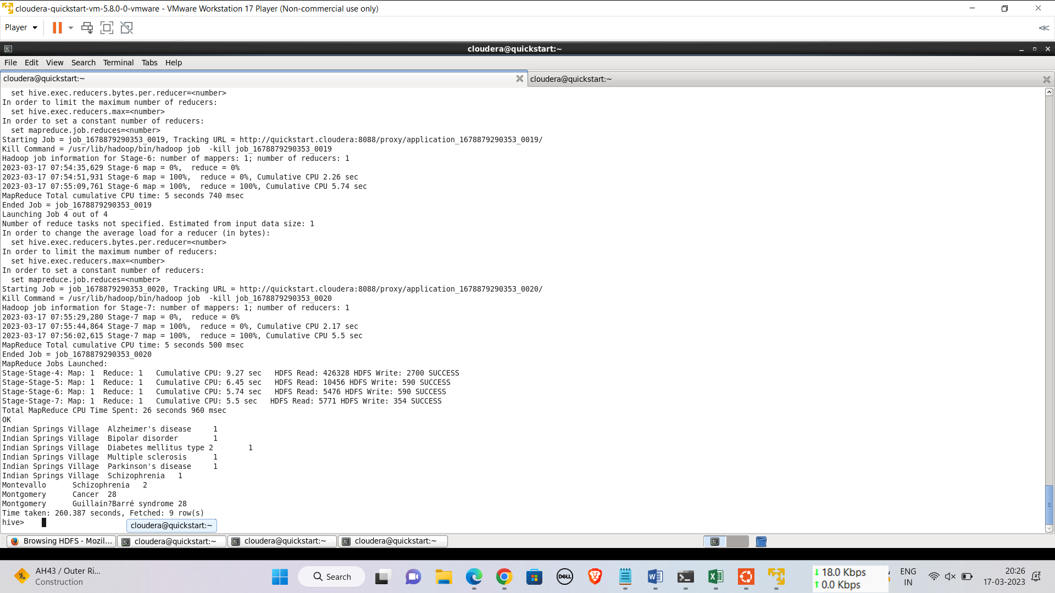

**External Table:**

hive> create external table out22(City string, Diseasename string, max int);

OK

Time taken: 0.335 seconds

hive> insert into out22 select * from p22;

**Sqoop Export:**

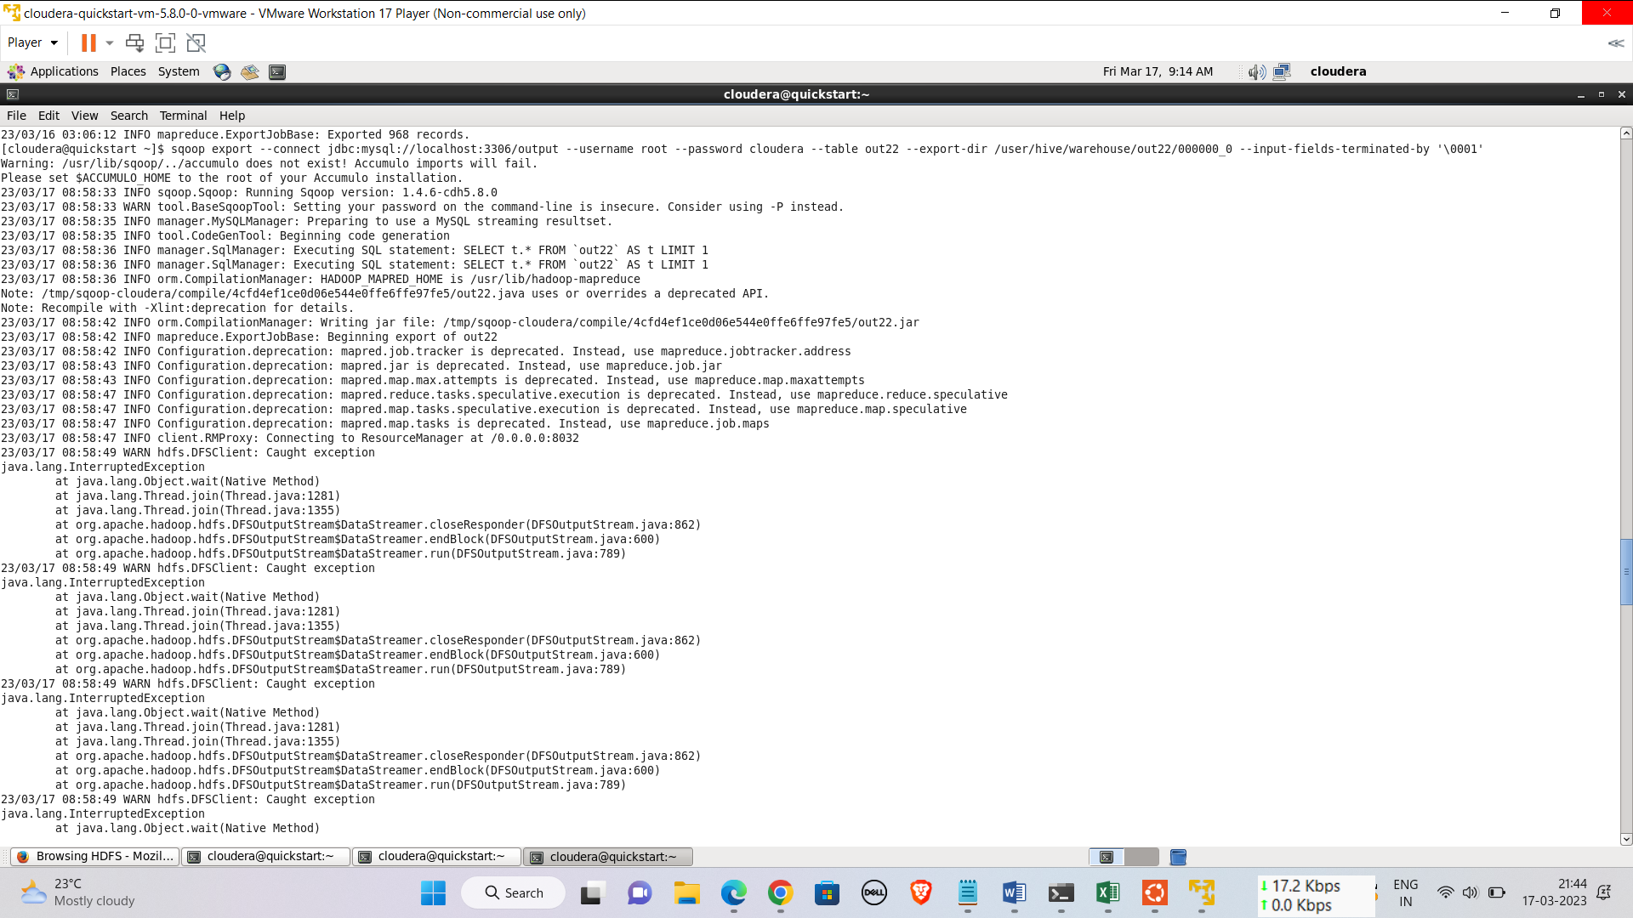

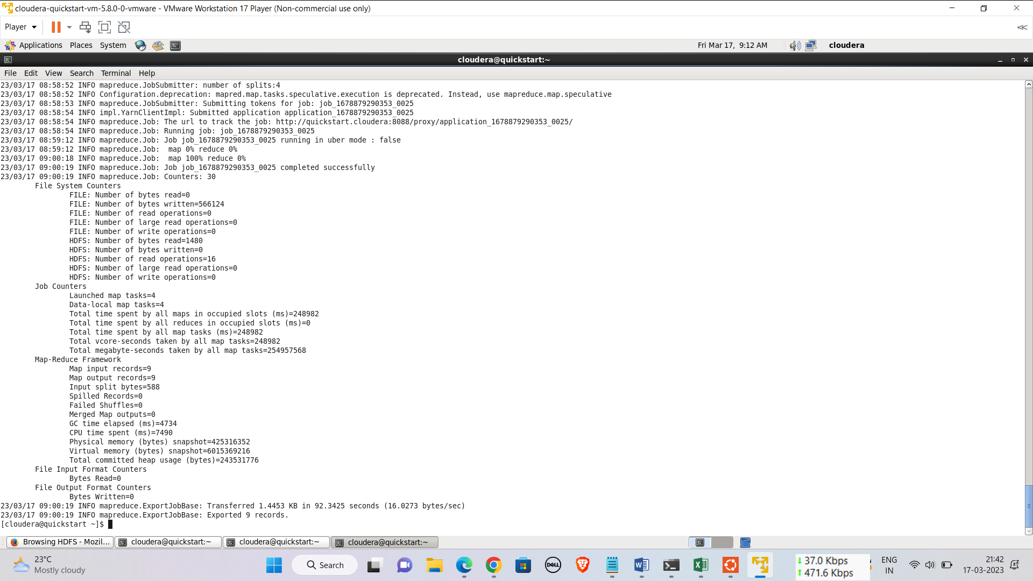

**=>8 Problem Statement 2- 5:**  An Insurance company wants a state wise report of the treatments to claim ratio between 1st April 2021 and 31st March 2022 (days both included). Assist them to create such a report.

**Hive Query:**

hive> create view p25 as select a.state, count(t.treatmentid), count(t.claimid), count(t.treatmentid)/count(t.claimid) from treatment t join person p on p.personid = t.patientid join address a on a.addressid = p.addressid where t.date>'2021-04-01' and t.date<'2022-03-31' group by a.state order by a.state;

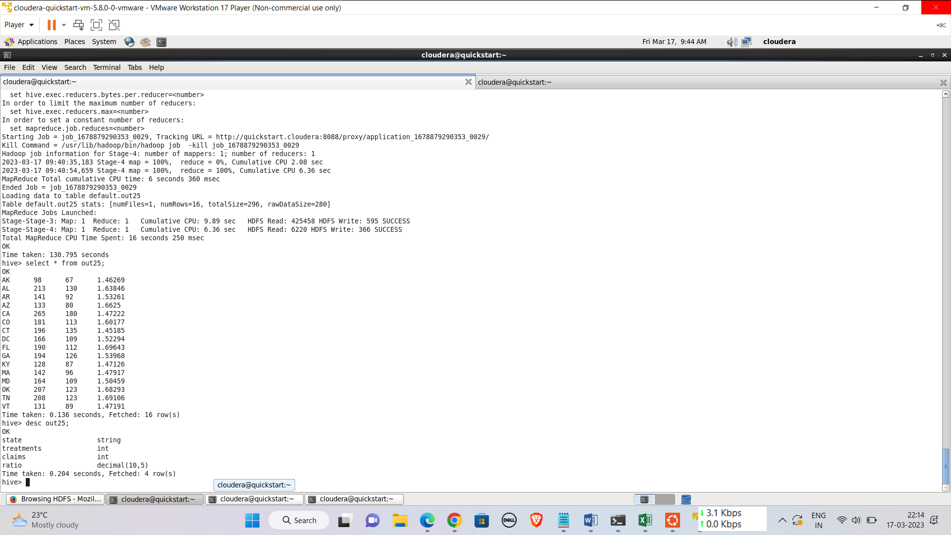

**External Table:**

hive> create table out25(State string, Treatments int, Claims int, Ratio decimal(10,5));

OK

Time taken: 0.235 seconds

hive> insert into out25 select * from p25;

**Sqoop Export:**

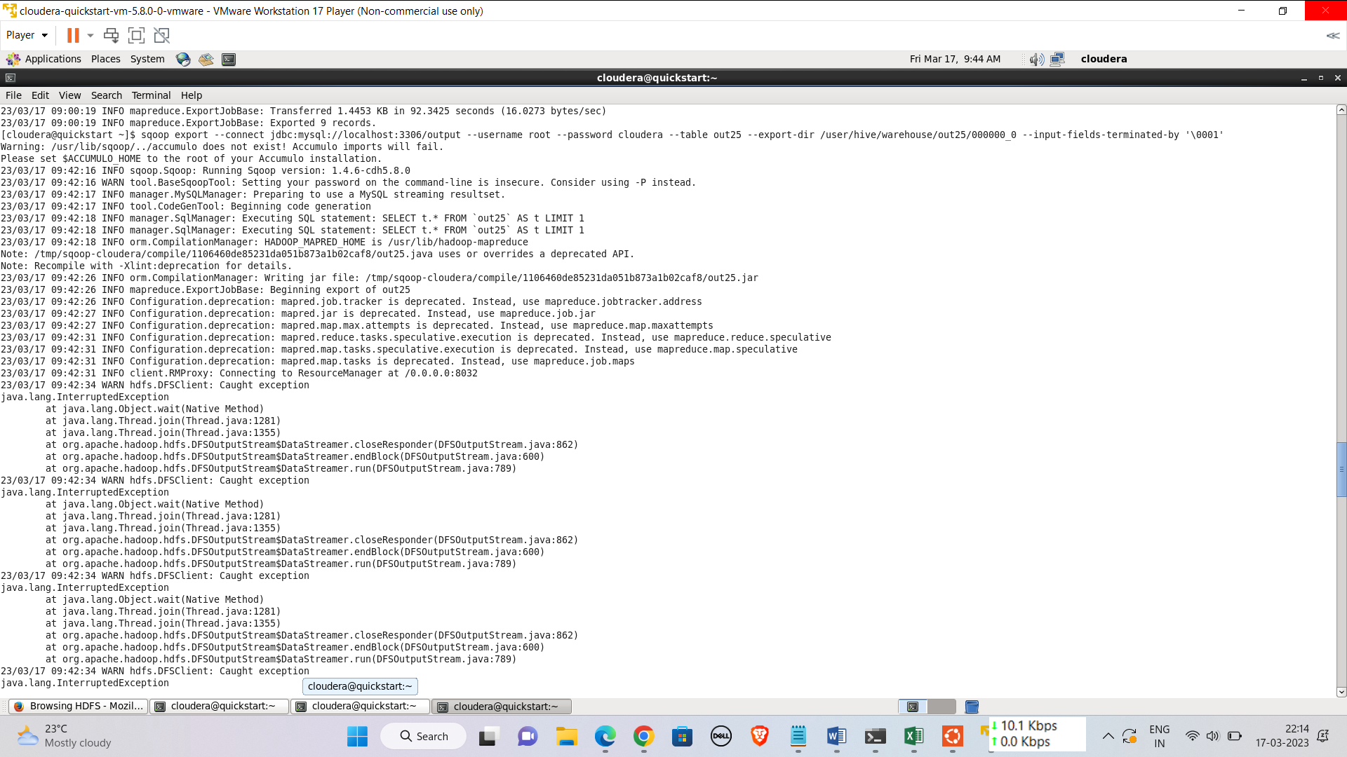

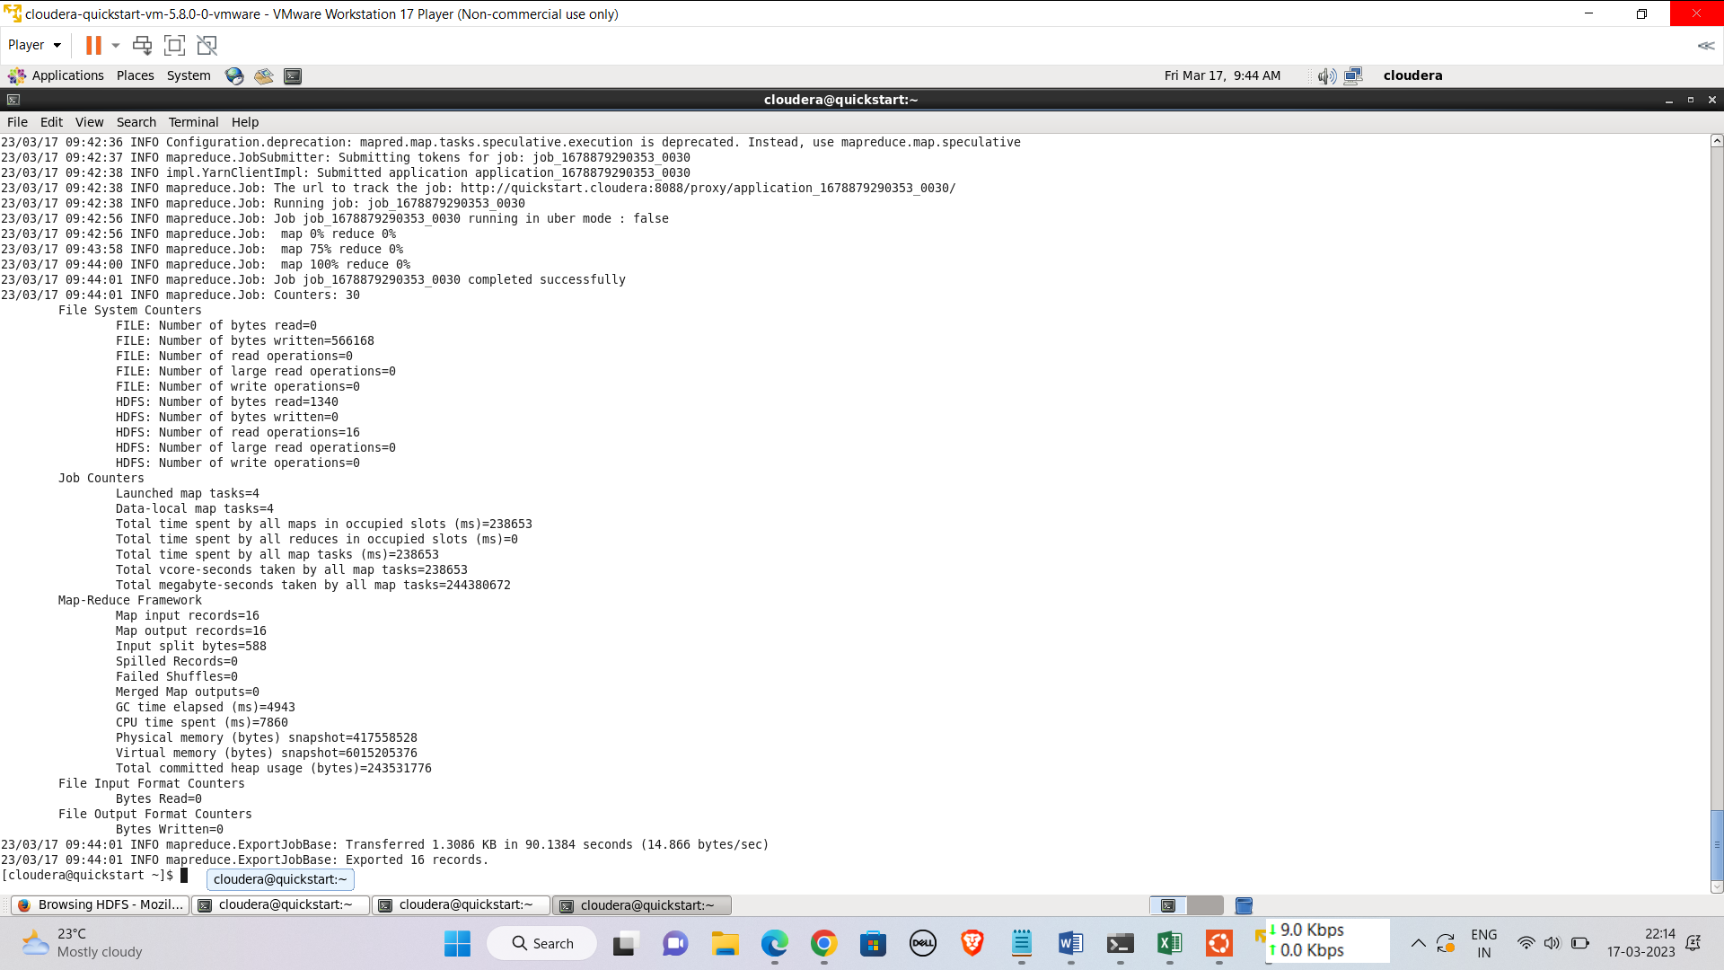

**=>9 Problem Statement 2:**

'Ally Scripts' pharmacy company wants to find out the quantity of medicine prescribed in each of its prescriptions.

Write a query that finds the sum of the quantity of all the medicines in a prescription and if the total quantity of medicine is less than 20 tag it as “low quantity”. If the quantity of medicine is from 20 to 49 (both numbers including) tag it as “medium quantity “and if the quantity is more than equal to 50 then tag it as “high quantity”.

Show the prescription Id, the Total Quantity of all the medicines in that prescription, and the Quantity tag for all the prescriptions issued by 'Ally Scripts'.

3 rows from the resultant table may be as follows:

***prescriptionID totalQuantity Tag***

*1147561399 43 Medium Quantity*

*1222719376 71 High Quantity*

*1408276190 48 Medium Quantity*

**Hive Query:**

create view p42 as select prescriptionid, sum(quantity) Quantity,(case when sum(quantity)<20 then 'Low Quantity'

when sum(quantity)>20 and sum(quantity)<49 then 'Medium Quantity'

else 'High Quantity' end)'Count' from contain group by prescriptionid order by prescriptionid;

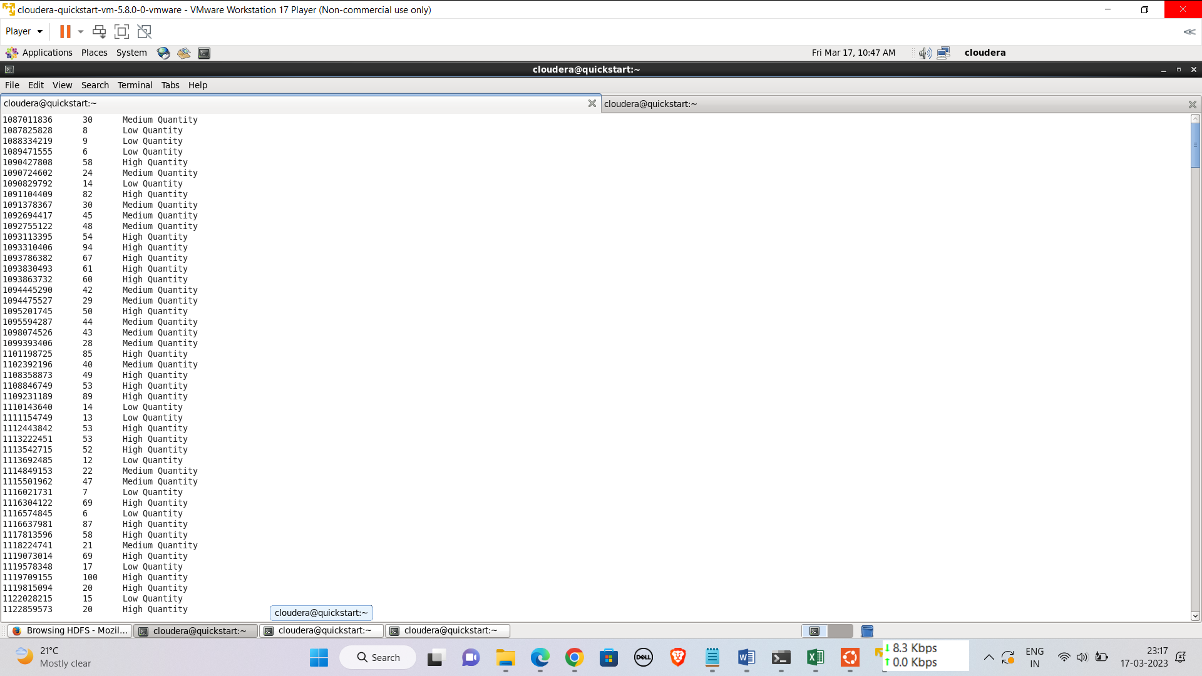

**External Table:**

hive> create table out42(prescriptionid int, quantity int,count string);

OK

Time taken: 0.235 seconds

hive> insert into out42 select * from p42;

**Sqoop Export:**

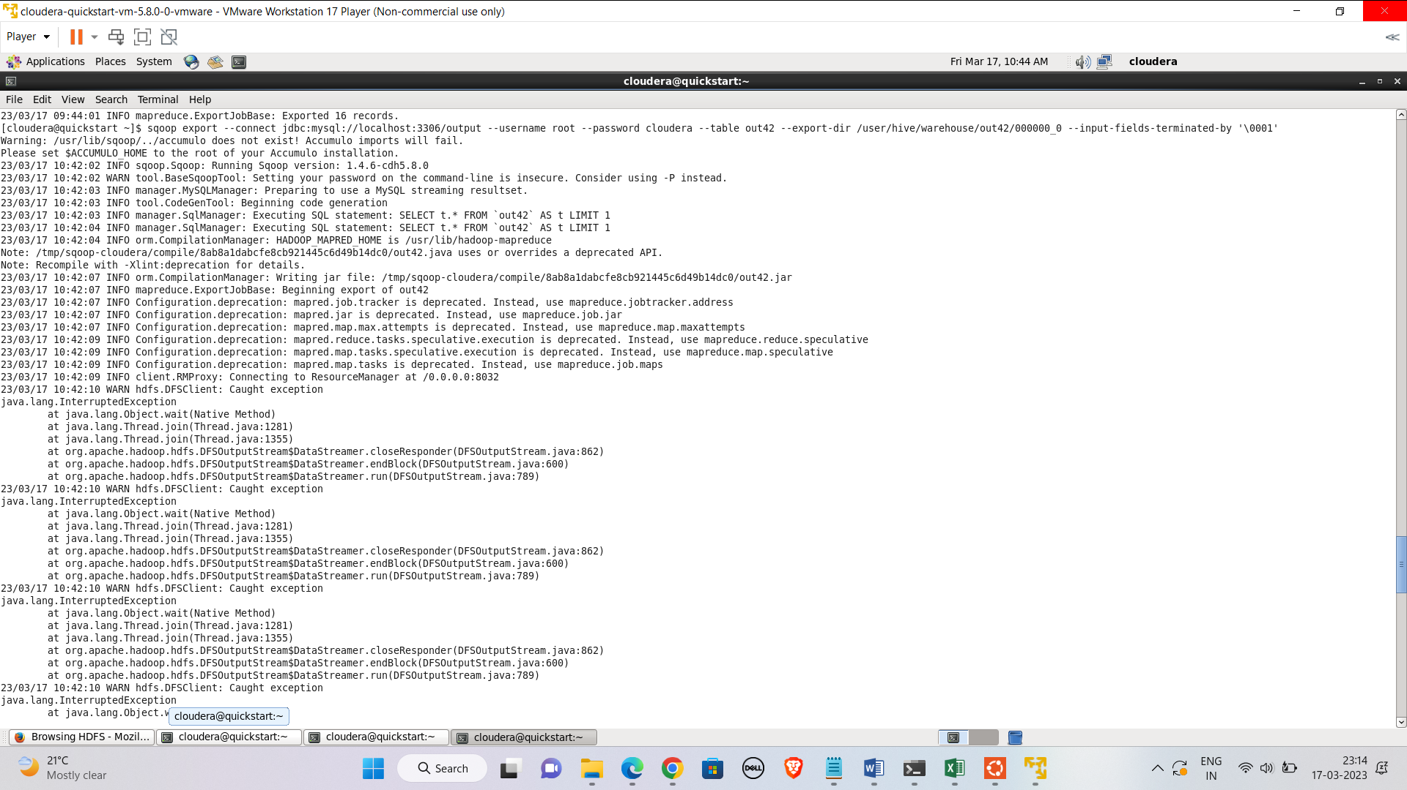

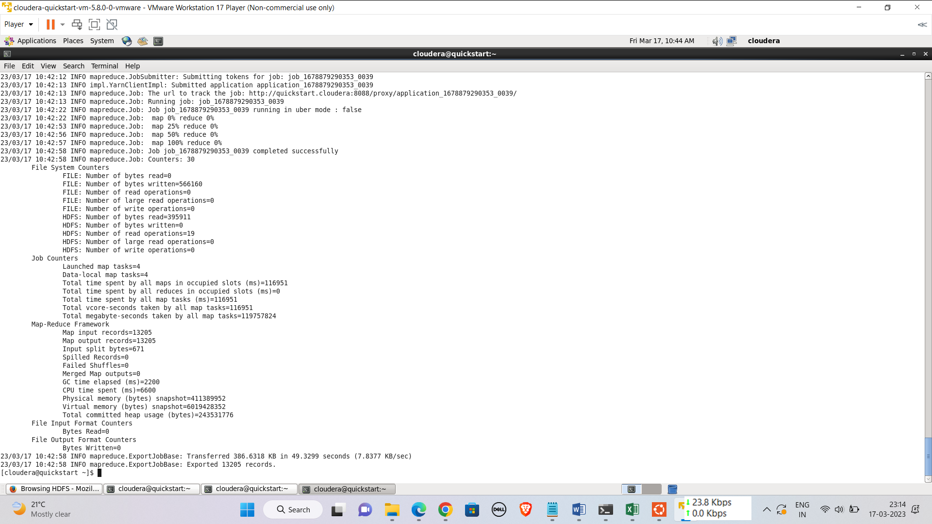

**=>10 Problem statement 5-1 Johansson is trying to prepare a report on patients who have gone through treatments more than once. Help Johansson prepare a report that shows the patient's name, the number of treatments they have undergone, and their age, Sort the data in a way that the patients who have undergone more treatments appear on top.**

**Hive Query:**

hive> create view p65 as select p.personname as personname,x.cnt as treatmentcount,cast(datediff('2023-03- 14',pa.dob)/365 as int) as age from (select t.patientid as patientid,count(t.treatmentid) as cnt from treatment t join patient p on p.patientid=t.patientid group by t.patientid having count(t.treatmentid)>1 order by 2)x join patient pa on pa.patientid=x.patientid join person p on p.personid=pa.patientid order by 2 desc;

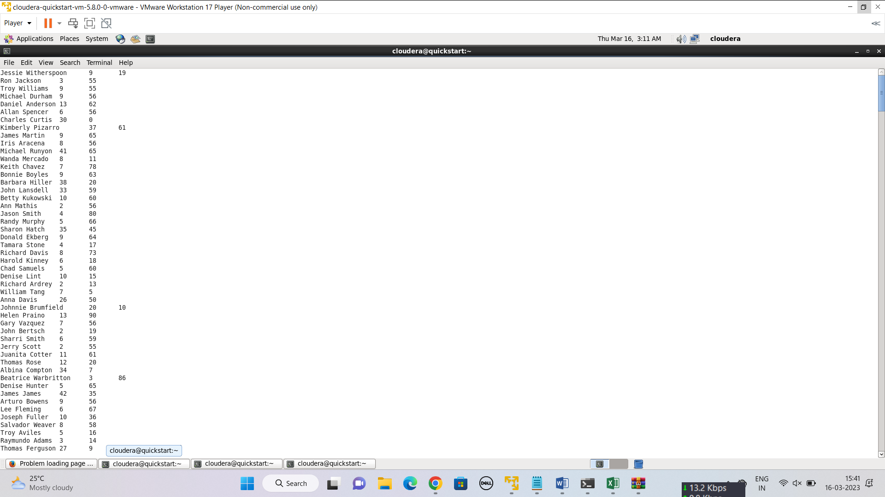

**External Table:**

hive> create external table out65(PersonName string, TreatmentCount int, Age int);

OK

Time taken: 0.274 seconds

hive> insert into out65 select * from p65;

**Sqoop Export:**

